**How is water distributed in the body?**

TBW accounts for 60% of weight of adult males (less in adult Females)

Less in Pregnant women (55%),

Elderly (50%)

More in Neonates (80%)

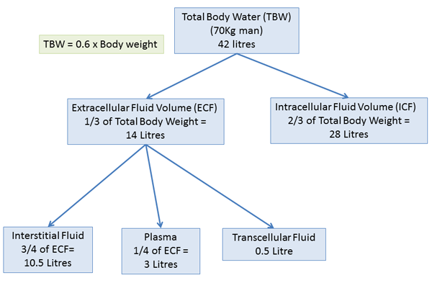

**How much of 1litre 0.9% Normal Saline remains in the plasma after infusion?**

It is isotonic therefore will distribute evenly within the extracellular compartment.

therefore 25% (250mls) will remain in the plasma.. therefore plasma would expand from 3.5L to 3.75L (7%) - enough to be detected by baroreceptors.

**How much of 1litre 5% Dextrose remains in the plasma?**

Dextrose (hypotonic) is freely taken up by all cells so is evenly distributed across all TBW compartments which means only 1/3 enters the ECF and so only 83mls enters the Plasma. so plasma volume only increase by 2% :- not enough to stimulate baroreceptors but enough to be detected by osmoreceptors and therefore ADH secretion will decrease and increase renal water excretion.

**What controls the distribution of fluid between intracellular and extracelluar compartments?**

the biphospholipid cell membrane separates compartments and allows ‘selective permeability’ so water can cross freely by osmosis (until osmolality is equal on both sides) but solutes cannot cross.

**What controls the water distribution between Plasma and Interstitial fluid?**

The capillary cell wall - movement across the capillary cell wall is passive due to filtration (Starling forces) and simple diffusion down concentration gradient

**How is plasma volume regulated?**

By controlling the movement of Na+ and thus water.

Extracellular Na+ is a balance of

1. Na+ intake
2. Extra-renal Na+ loss e.g sweating
3. Renal Na+ Excretion

The kidney is essentially responsible for plasma Na+ regulation as it can significantly vary Na+ excretion therefore the Kidney is the Key regulator of Plasma Volume.

Net Na+ Loss = Volume reduction

Net Na+ gain = Volume expansion.

**What factors regulate Body Water?**

Water balance governs Intracellular fluid

Sodium balance governs Extracellular fluid

TBW regulated by ADH - acts on V2 receptors in collecting tubule.

ADH secreted in response to:

1. Hyperosmolality - detected by osmoreceptors at Hypothalamus
2. Volume depletion of ECF detected by low pressure + high pressure baro-receptors.
3. Ang 2
4. Other: pain. exercise, stress, emotion, n+v, nicotine, morphine

ADH selection inhibited by;

1. low osmolality
2. increased ECF volume
3. Alcohol